**EXPERIMENT-8**

**Submitted by:**Ajay Kumar Tyagi  
500067403  
R171218008  
CSE-DevOps 2018-2022

**Aim-** Implementing Docker ignore.

**Procedure:**

**1)** Use command **cat Dockerfile** to see inside the steps of Dockerfile. Our app folder contains password.txt file which is sensitive.  
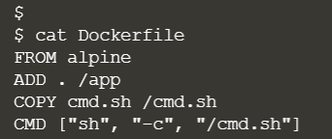

**2)** Use command **docker build** to build this Dockerfile.  
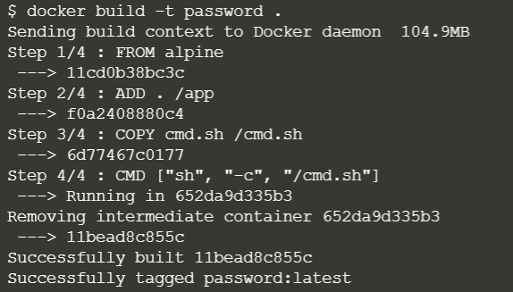

**3)** Now if you see content by starting container from this image, you will see this also contains password.txt file.  
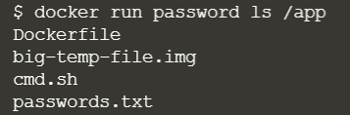

**4)** To ignore these sensitive files, we can use .dockerignore. Create a .dockerignore file and inside this file write those files name which you want to ignore when building docker image.  
Now if you build image you will see the container will not contain password.txt file.  
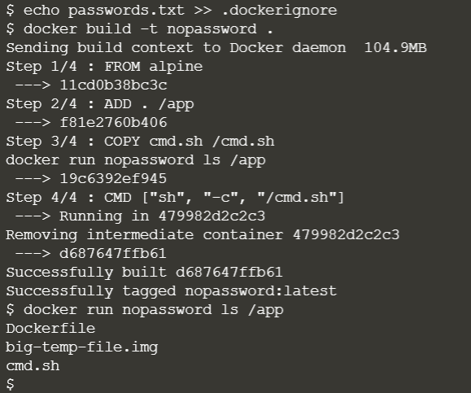

**5)** .dockerignore can also be used to improve the build time of images. For example, suppose an app folder contains 100 mb of temporary file. Since these files are not required further, these will simply increase build time.  
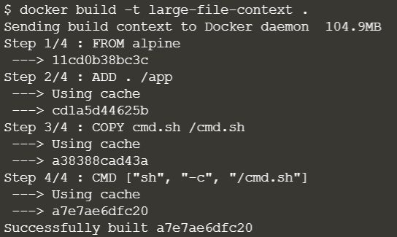

**6)** We can use .dockerignore to exclude files which we don't want to be sent to the Docker Build Context during the build. To speed up our build, simply include the filename of the large file in the ignore file. When we rebuild the image, it will be much faster as it doesn't have to copy the 100M file.  
